**Internship Assignment Report: Cyber Security and Digital Forensics**

**Assignment 6:**

* **Portswigger:**

1. https://portswigger.net/web-security/access-control/lab-unprotected-admin-functionality
2. https://portswigger.net/web-security/access-control/lab-unprotected-admin-functionality-with-unpredictable-url
3. https://portswigger.net/web-security/access-control/lab-user-role-controlled-by-request-parameter
4. https://portswigger.net/web-security/access-control/lab-user-role-can-be-modified-in-user-profile
5. https://portswigger.net/web-security/access-control/lab-user-id-controlled-by-request-parameter
6. https://portswigger.net/web-security/access-control/lab-user-id-controlled-by-request-parameter-with-unpredictable-user-ids
7. https://portswigger.net/web-security/access-control/lab-user-id-controlled-by-request-parameter-with-data-leakage-in-redirect
8. https://portswigger.net/web-security/access-control/lab-user-id-controlled-by-request-parameter-with-password-disclosure
9. https://portswigger.net/web-security/access-control/lab-insecure-direct-object-references
10. https://portswigger.net/web-security/access-control/lab-url-based-access-control-can-be-circumvented
11. https://portswigger.net/web-security/access-control/lab-method-based-access-control-can-be-circumvented
12. https://portswigger.net/web-security/access-control/lab-multi-step-process-with-no-access-control-on-one-step
13. https://portswigger.net/web-security/access-control/lab-referer-based-access-control

**About Me**

* **Name:** Yugander Chanupalli
* **Position:** Cyber Security and Digital Forensics
* **Organization:** CyberSecured India
* **Email:** yugander9010@gmail.com
* **Submission Date:** 25/09/2024

**PortSwigger**

**Let’s solve labs one by one:**

**Lab 1:** <https://portswigger.net/web-security/access-control/lab-unprotected-admin-functionality>

As title mentioned there is a unprotected admin functionality in application it allows us to get access to admin panel and there we can perform any action.

So, I just started watching source page because most of the hidden functionalities are defined there. After, I didn’t found any interesting and I simply opened the robots.txt file it is most common file to check about website directories. There the developer mentioned the disallowed directory. As we can see the below image to understand better.

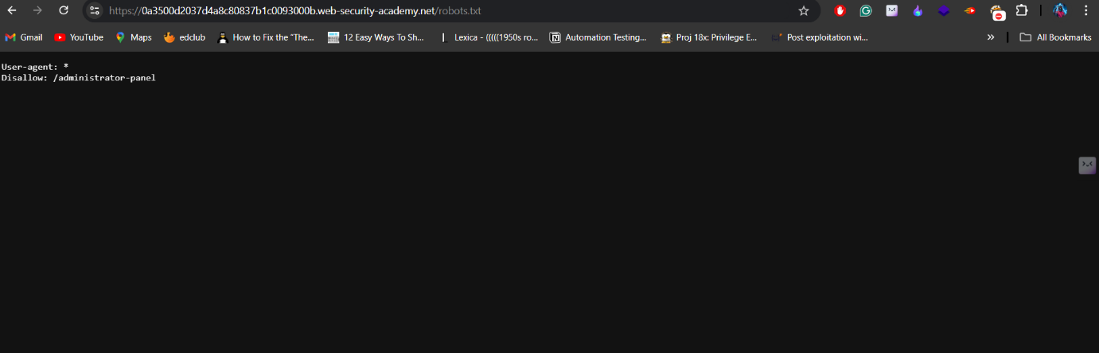

Most of these disallowed would not work as developers might protect them because they are publicly available. But, As a security student I need to check the protection of this directory unfortunately, it does not have any protection when I added this parameter at the last then It is redirected to admin panel where I have access to all the users.

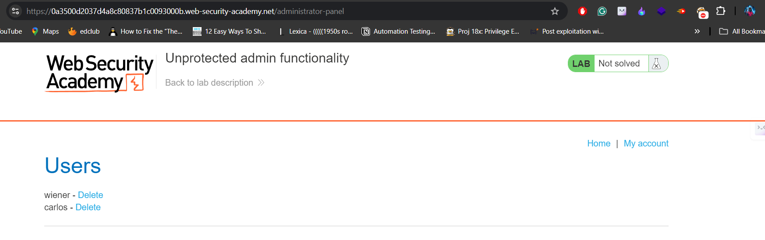

As per our task I have to delete the user carlos to complete the lab.

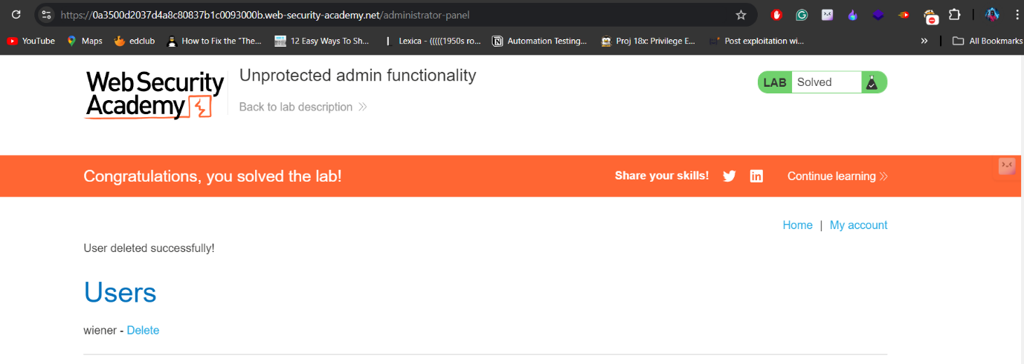

**Lab 2:** <https://portswigger.net/web-security/access-control/lab-unprotected-admin-functionality-with-unpredictable-url>

I went through the similar process and found that there is a javascript code in source page and it contains a hidden parameter so I used it to modify the url and I successfully gained access through admin panel.

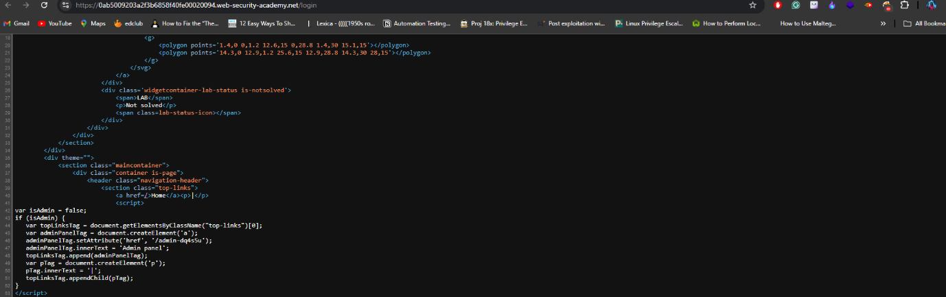





**Lab 3:** <https://portswigger.net/web-security/access-control/lab-user-role-controlled-by-request-parameter>

Every page is displayed to us using requests right. To Analyse these requests we can intercept them using burpsuite intercept option. So, I started intercepting every request from login and found that there is one parameter called admin is also passing through client side and by default it is set to false. Immediately I changed it to true and the page rendered the admin panel so then I deleted the carlos.

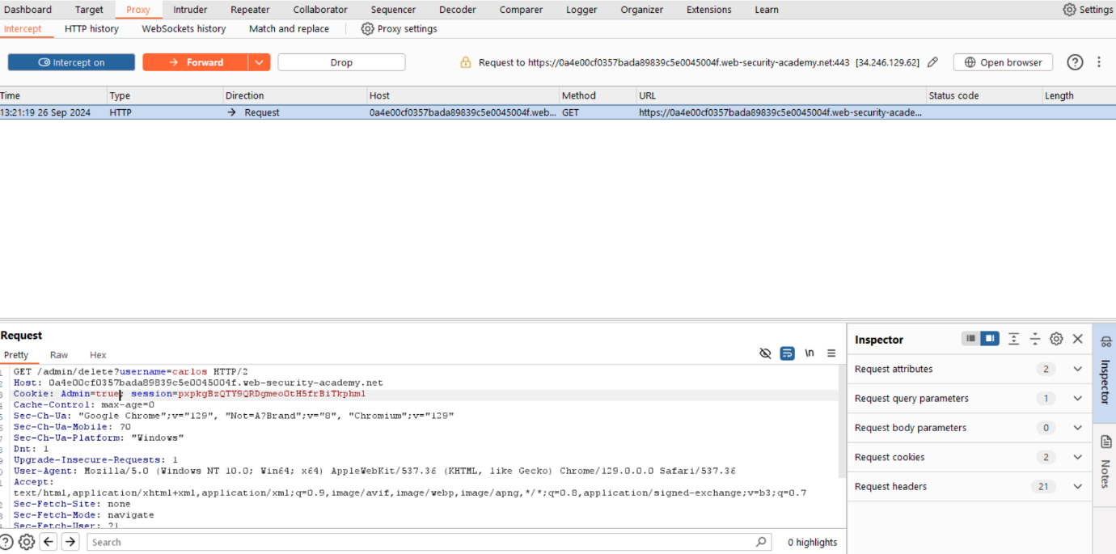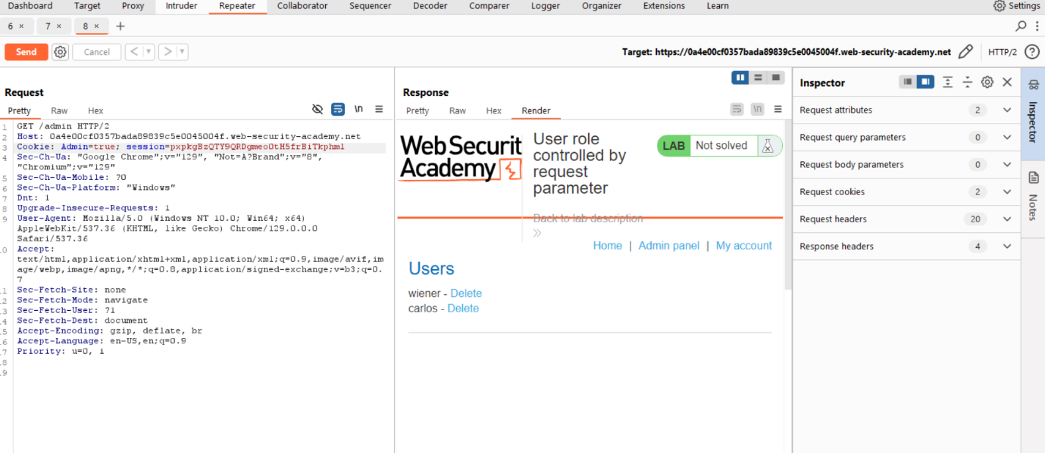

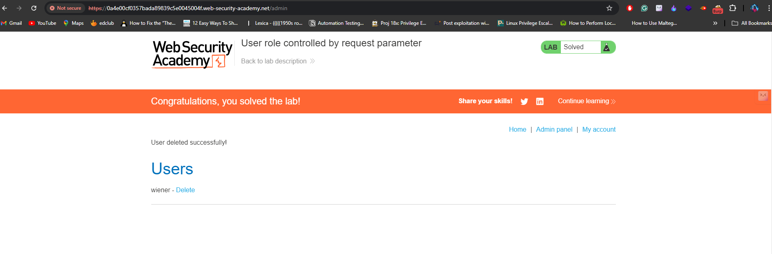

**Lab 4:** <https://portswigger.net/web-security/access-control/lab-user-role-can-be-modified-in-user-profile>

I found this is some what challenging when solving because upto here we solved directly using visible data I mean we just tampered the application using the data provided on source pages and all. But, Here the case is very different the request doesn’t give any hints after a lot of time I tried to intercept the response of email update request and it is one and only option to get admin panel all other are carefully protected. So, After inspecting the response it contains one roleid field set to 1. Again, I reloaded the page and this time I added the roleid to 0 and it doesn’r worked for me so I added 2 then it is worked. Finally, I managed to delete the user called carlos.

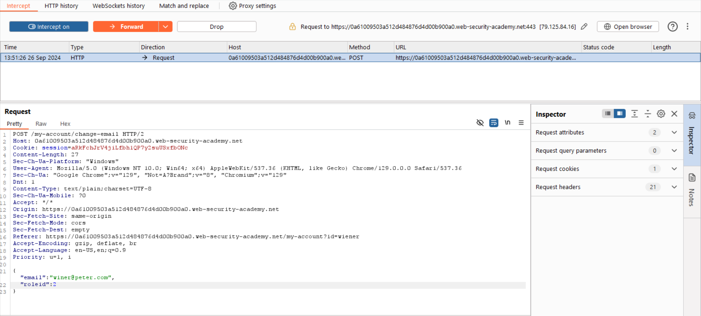

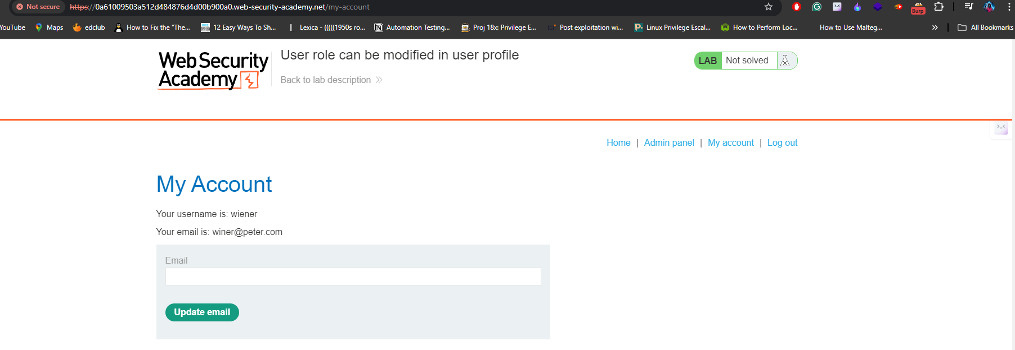

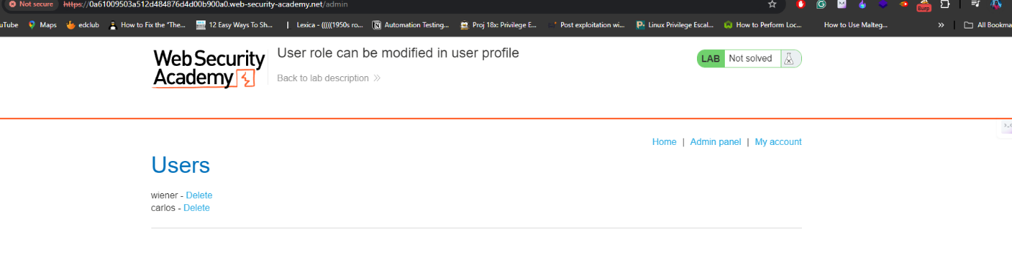

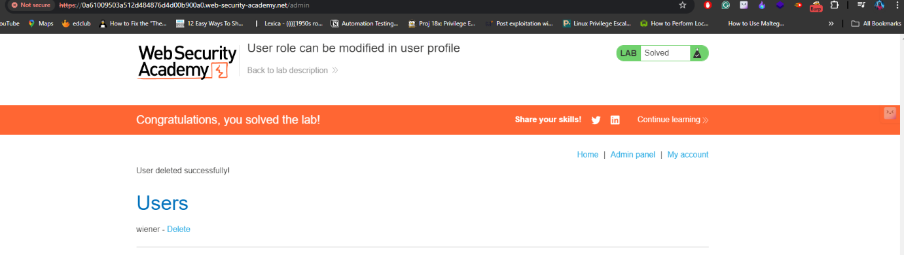

**Lab 5:** <https://portswigger.net/web-security/access-control/lab-user-id-controlled-by-request-parameter>

It takes very less time for me as usual I started to intercept the all requests and at the same time I forwarded them to repeater and one of the requests in them is interesting where the application is using the id to retrieve the details of account so I just changed the id value to carlos then I got carlos details as response.

Then i copied the api key and submitted on application.

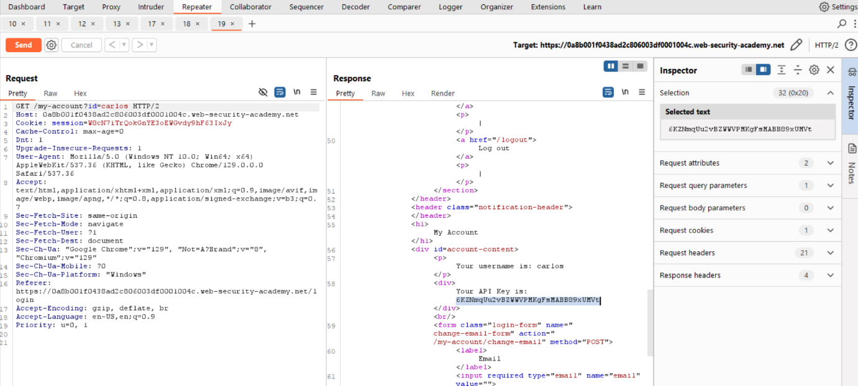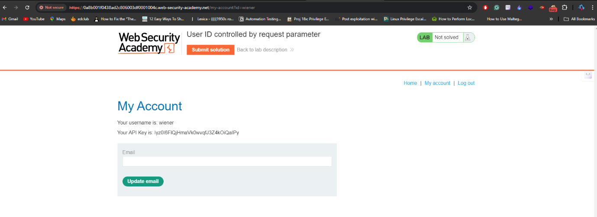

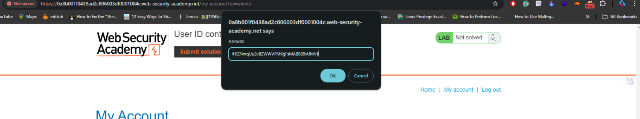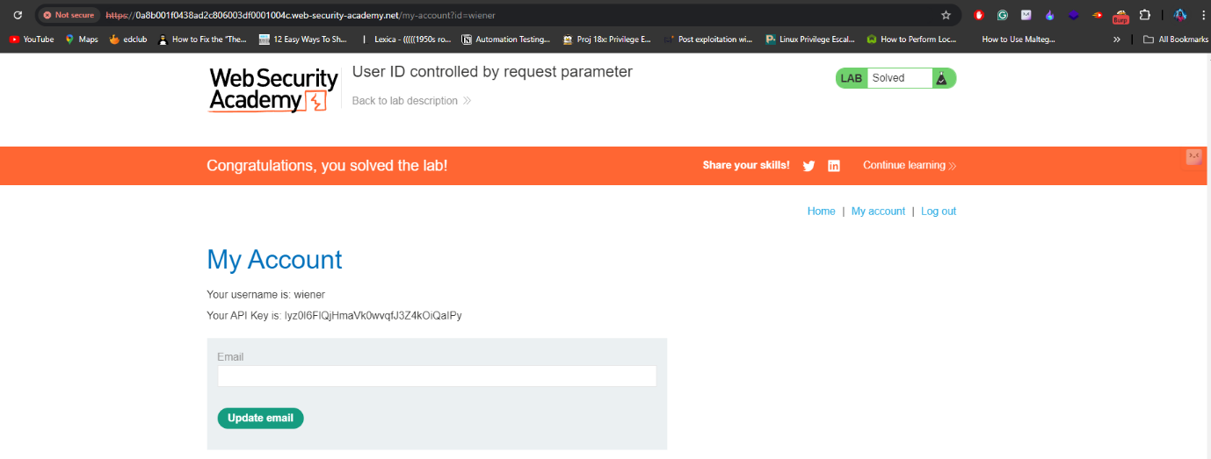

**Lab 6:** <https://portswigger.net/web-security/access-control/lab-user-id-controlled-by-request-parameter-with-unpredictable-user-ids>

In this lab the id value is not used directly, First I tried to find the other possibilities include’s modifying the session and csrf token but none of them worked. Through this lab I learned how cookies and sessions works by analysing every requests. After sometime I realized to find other ways on application and I checked the blogs with the usernames and one blog is posted by our carlos so I captured that request I found the value.

From here I just added the above found value in id field during interception and server returned carlos details which includes the api key.

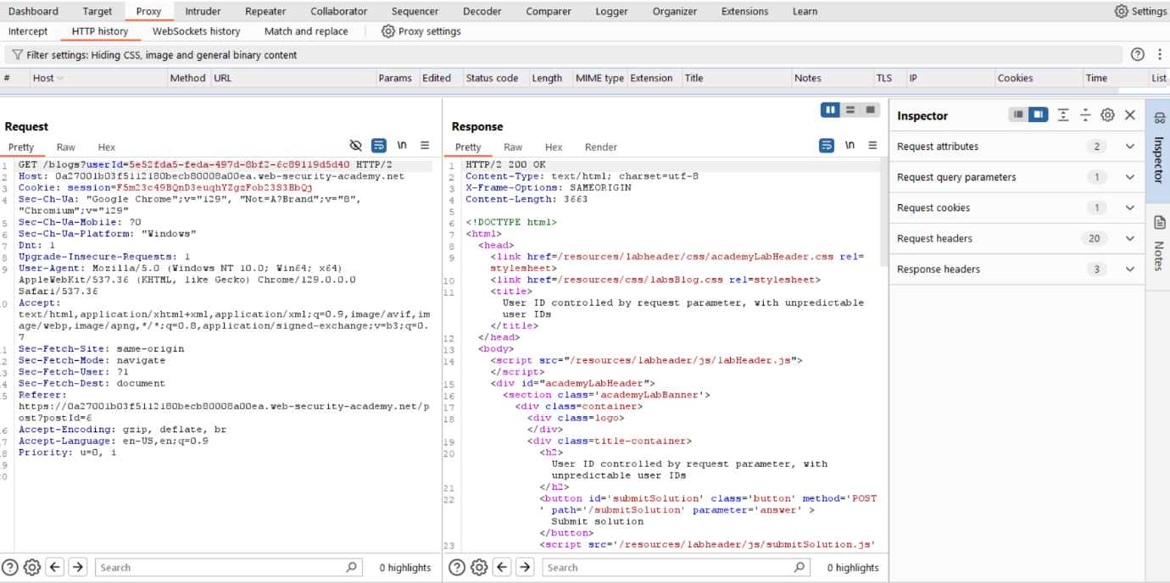

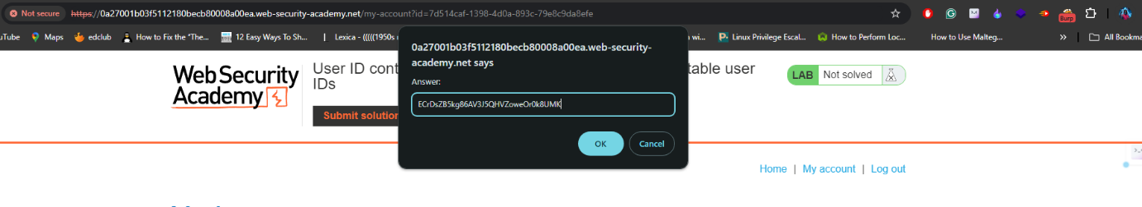

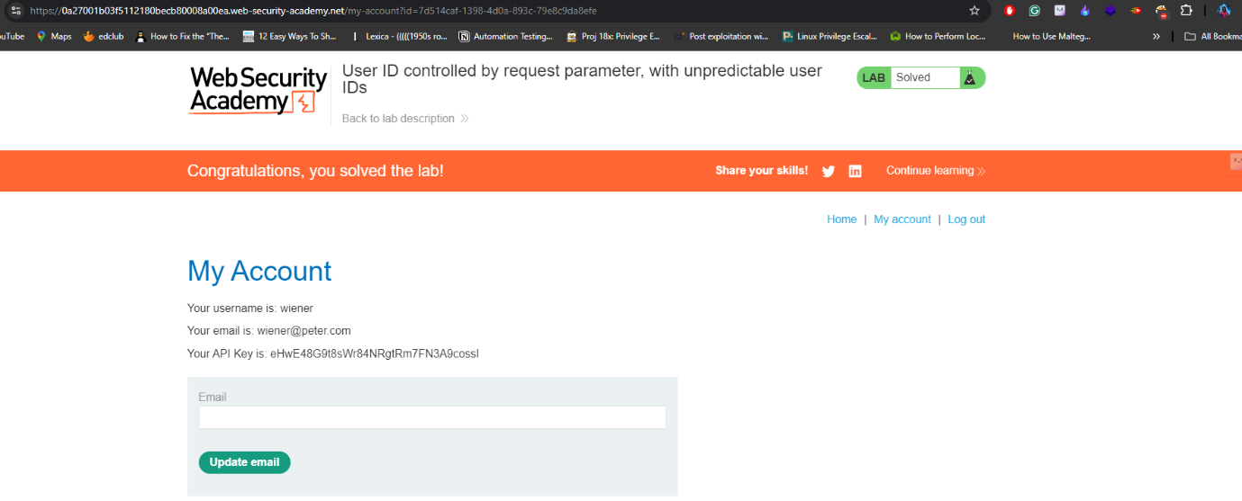

**Lab 7:** <https://portswigger.net/web-security/access-control/lab-user-id-controlled-by-request-parameter-with-data-leakage-in-redirect>

Similar, Process Intercepted all the request when logging with my valid credentials during this process one request is using id parameter to retrieve the data from server then I changed the id value to carlos using repeater and response contains the api key.

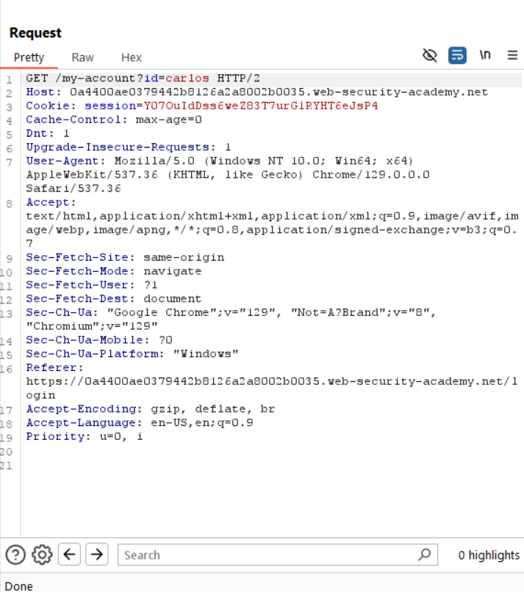

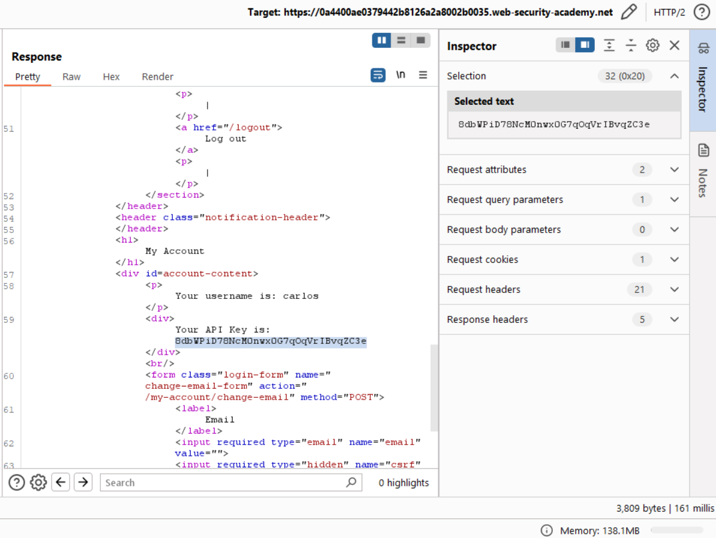

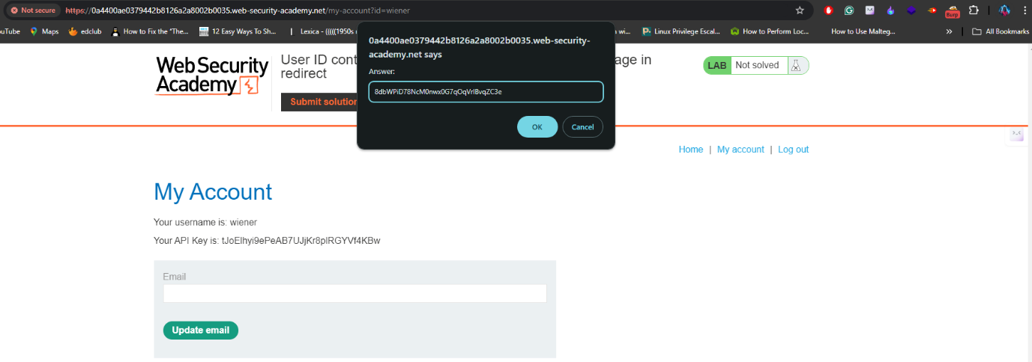

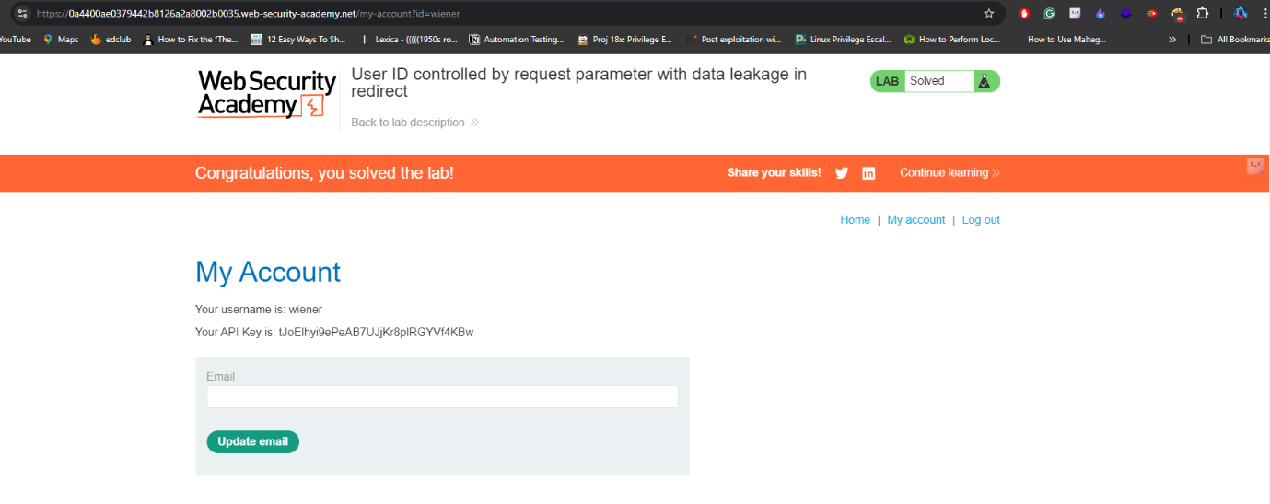

**Lab 8:** <https://portswigger.net/web-security/access-control/lab-user-id-controlled-by-request-parameter-with-password-disclosure>

According to title it is saying that the password disclosure is possible. I started capturing all the requests when I am logging into the site and I found that again the application is using the same request id to fetch details but now I am not sure weather it works or not but after capturing requests I went to repeater to check if it is working or not surprisingly it is working when I passed the request by changing the user id to administrator. So, to find the password I inspected the website and changed the password type to text and I copied that password to login as admin. Now, our final task I deleted the user carlos.

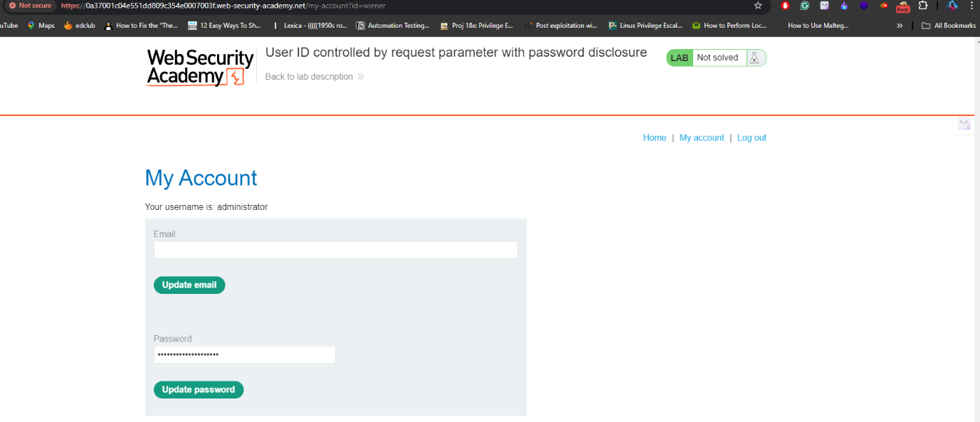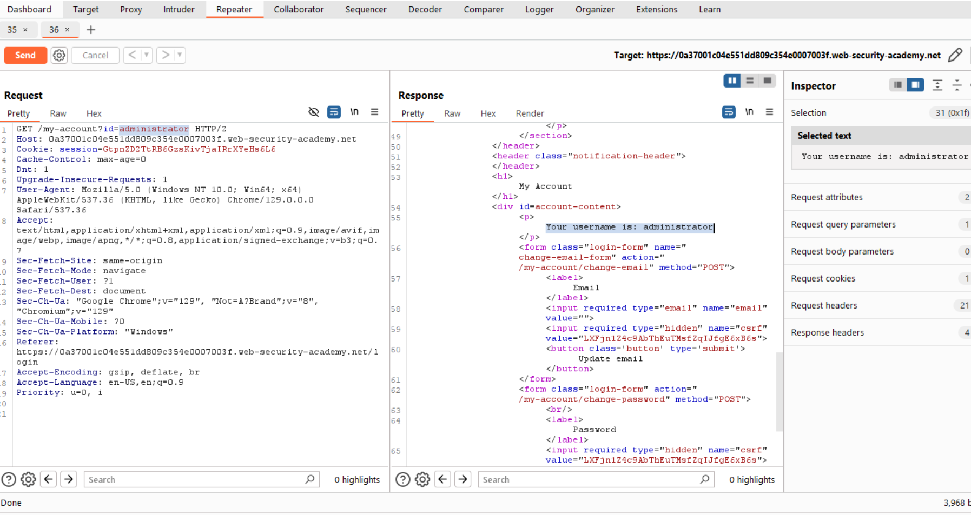

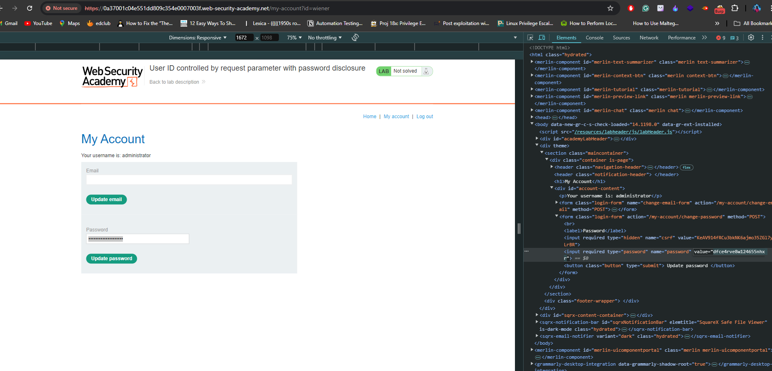

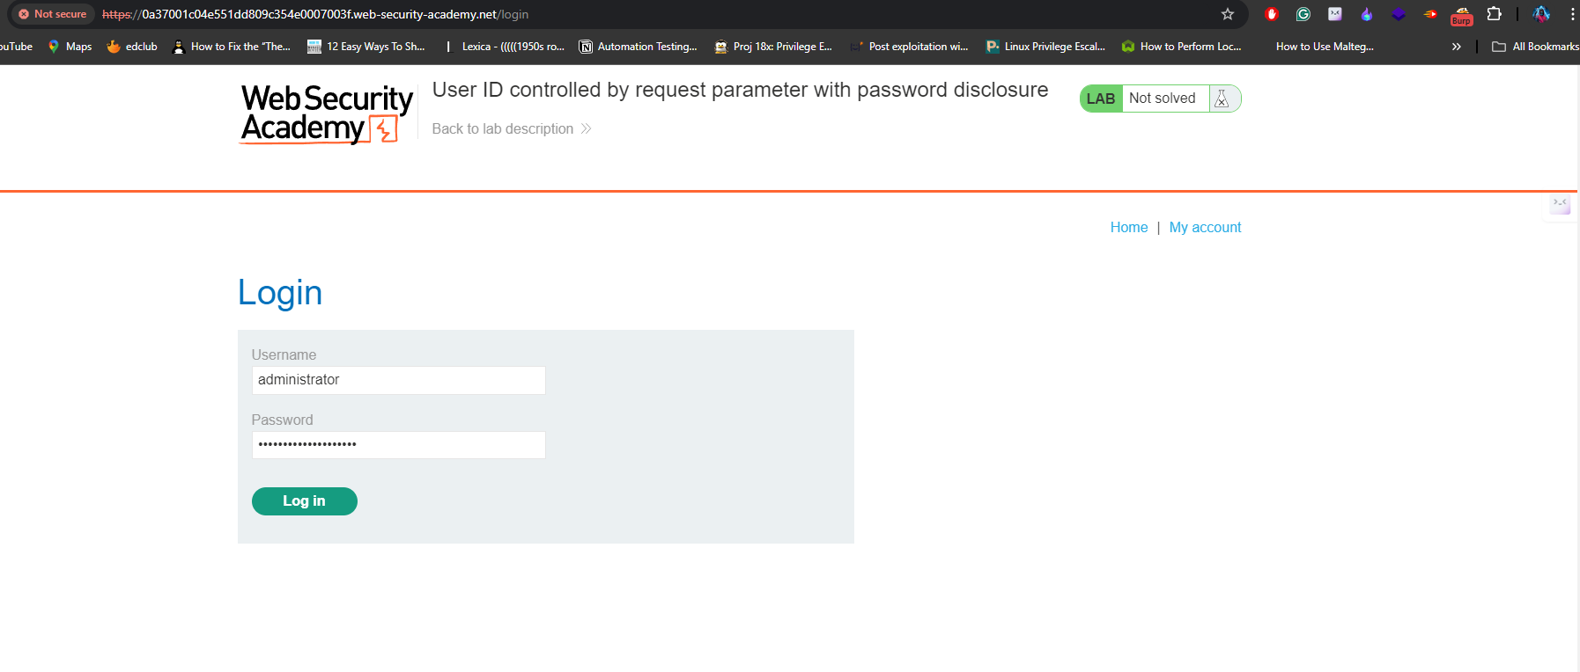

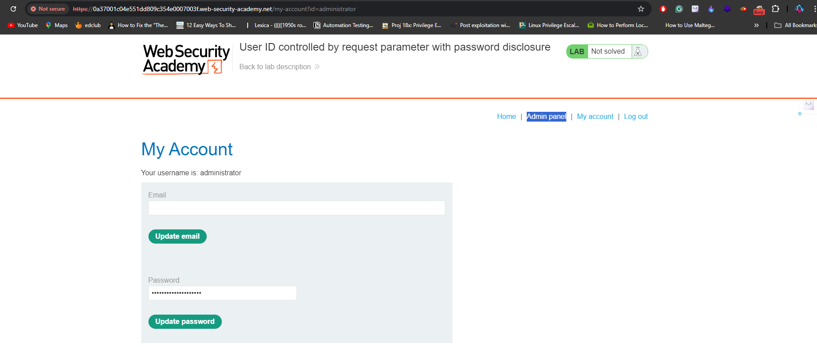

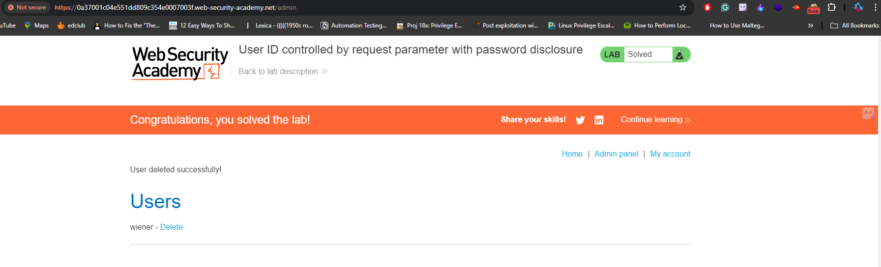

**Lab 9:** <https://portswigger.net/web-security/access-control/lab-insecure-direct-object-references>

In this lab I started exploring application functionalities and found live chat option is the only option to exploit so, I started intercepting the request which are related to transcript. When I click the transcript is retrieving the file from server that contains the information about my chat. So, when I modified the name of the file the server is responding with sensitive data.

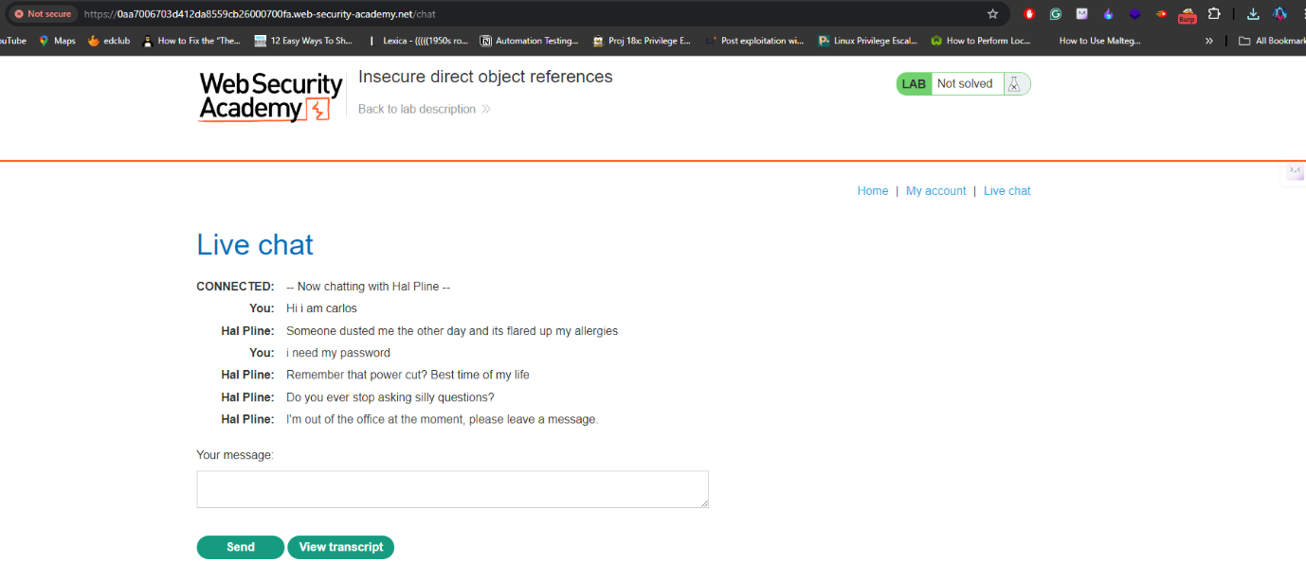

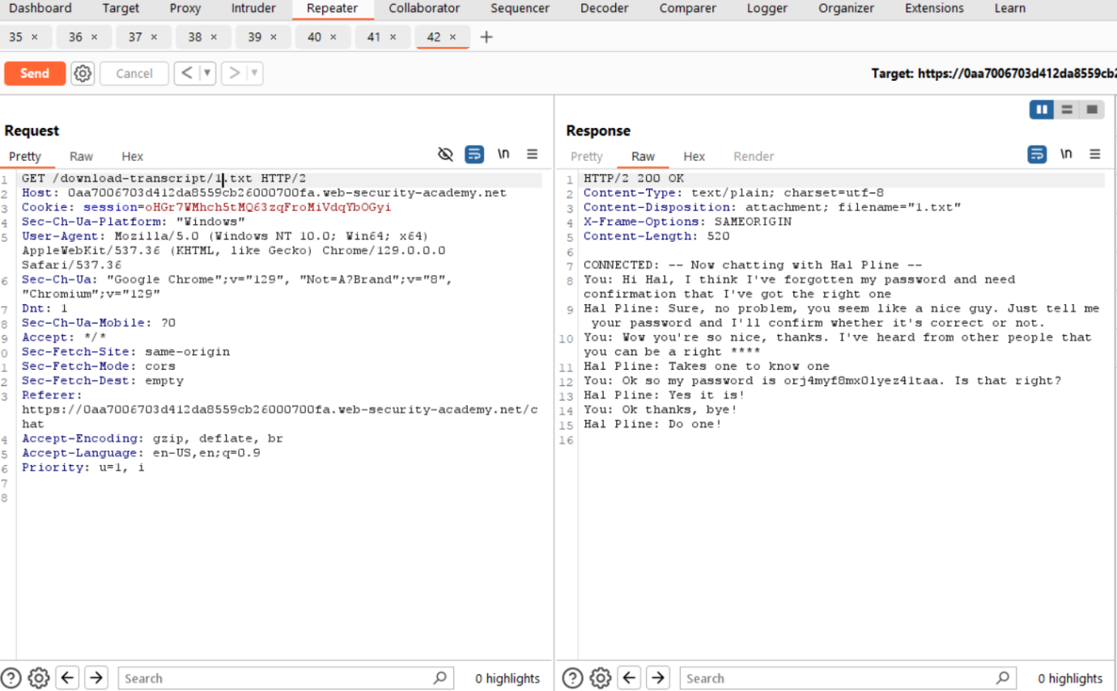

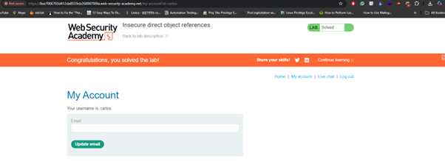

**Lab 10:** <https://portswigger.net/web-security/access-control/lab-url-based-access-control-can-be-circumvented>

In this lab I used the header called x-original-url it is used to override the actual header. so when I tried to access the /admin page it returned forbidden response. so I tried again after adding header then it worked well.

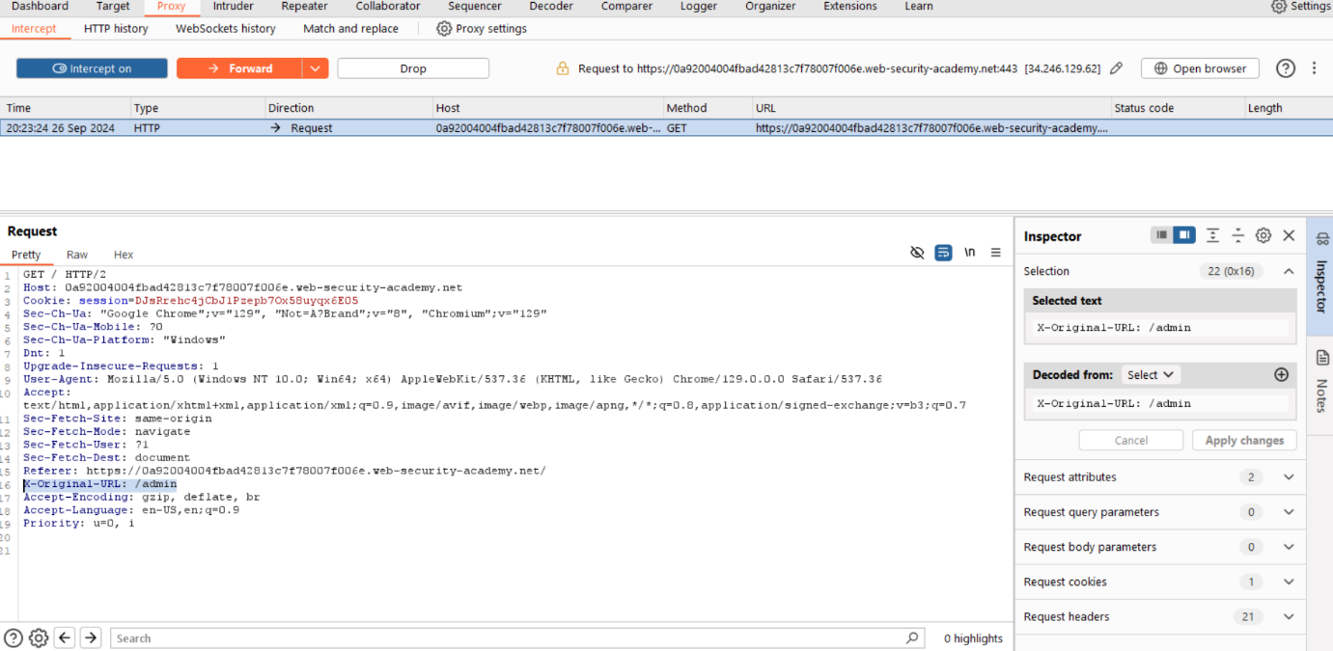

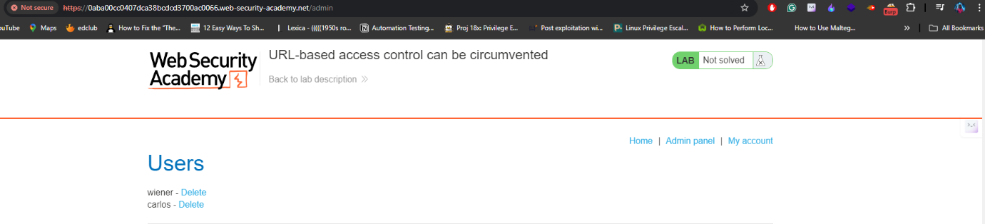

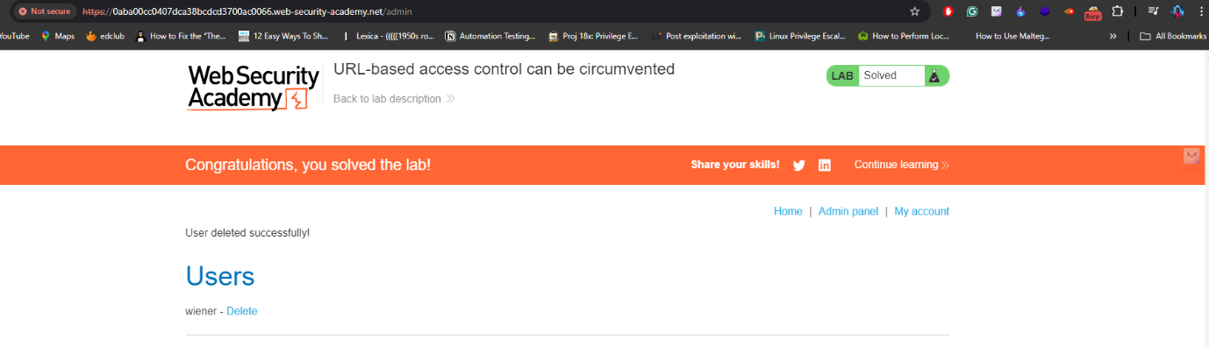

**Lab 11:** <https://portswigger.net/web-security/access-control/lab-method-based-access-control-can-be-circumvented>

In this lab the vulnerability exists on http methods here the admin has capacity to upgrade or degrade any user now I changed the level of carlos user and intercepted the request and then I logged into normal account and captured the request on burpsuite and now I tried to change upgrade the normal user level to admin level but it returned error as unauthorized. But, there is a situation is possible when some requests could not implemented correct way. So if we trigger them then we can easily achieve the output.

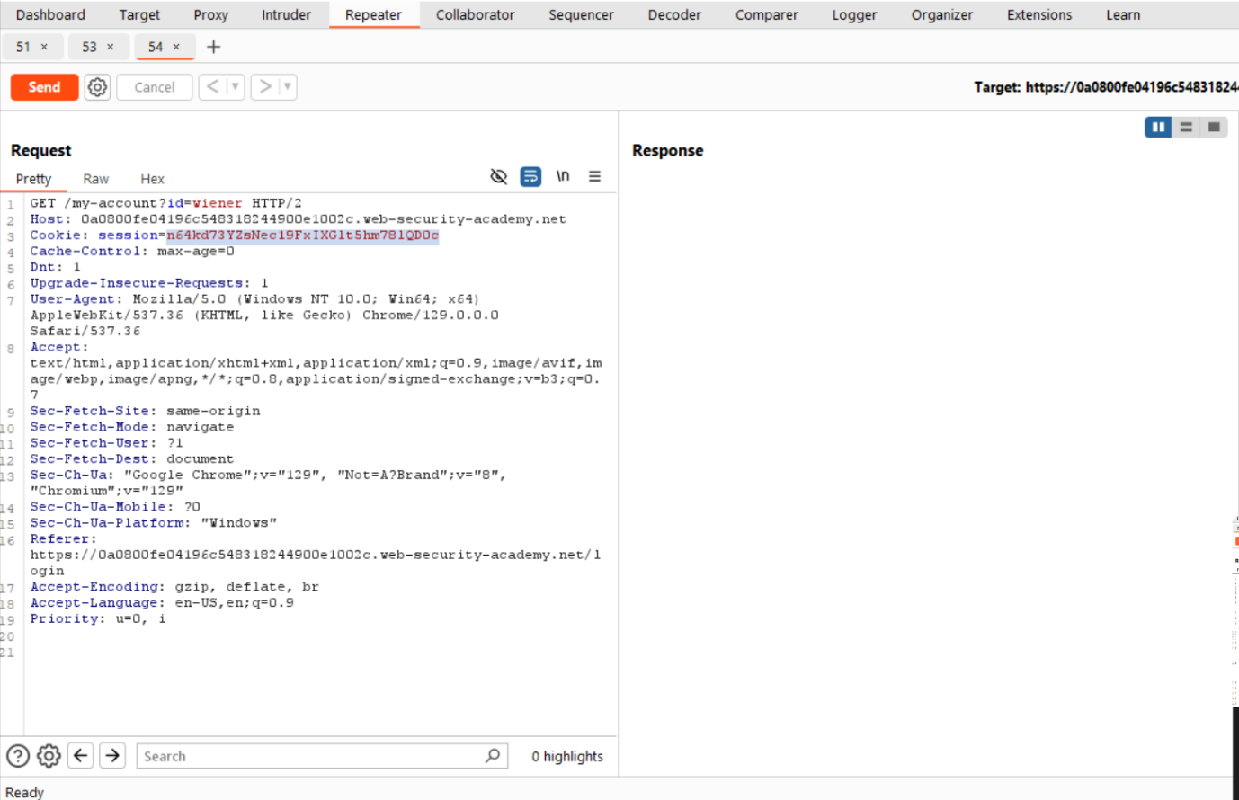

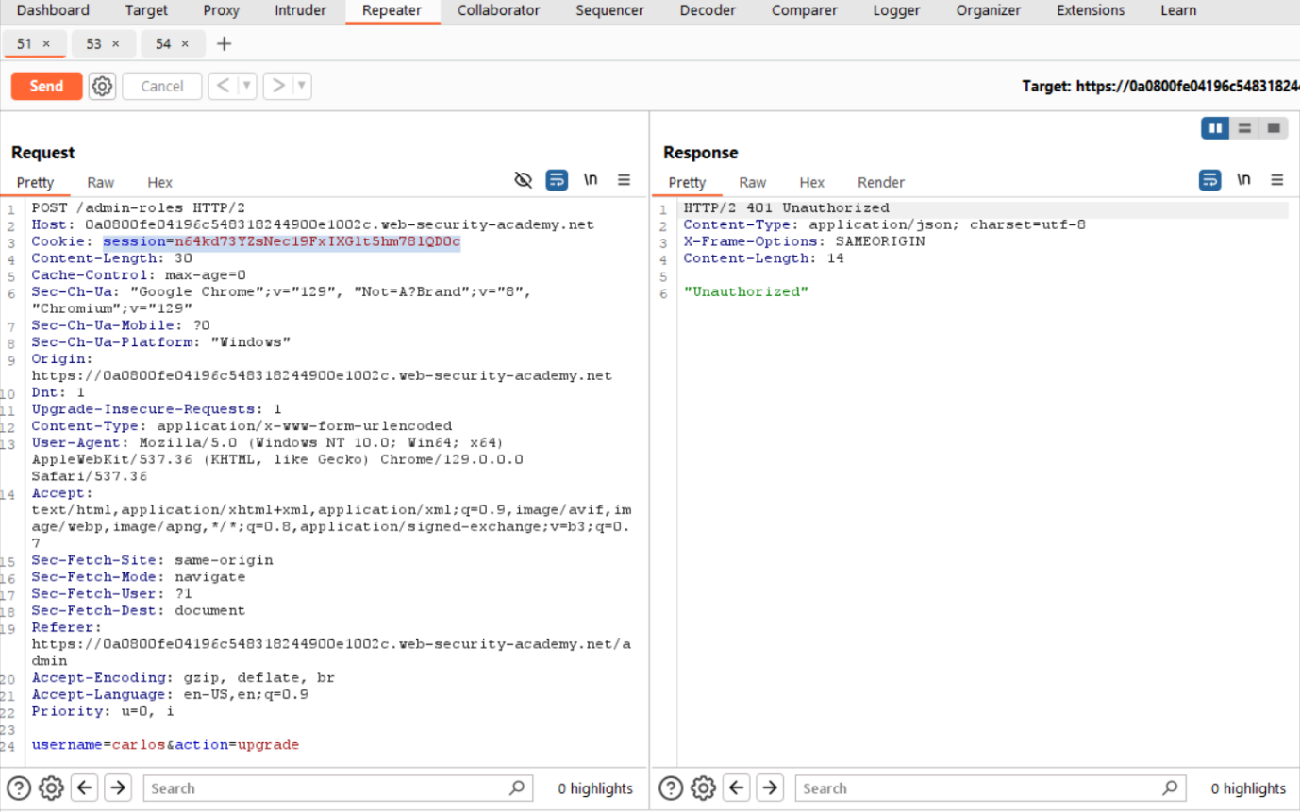

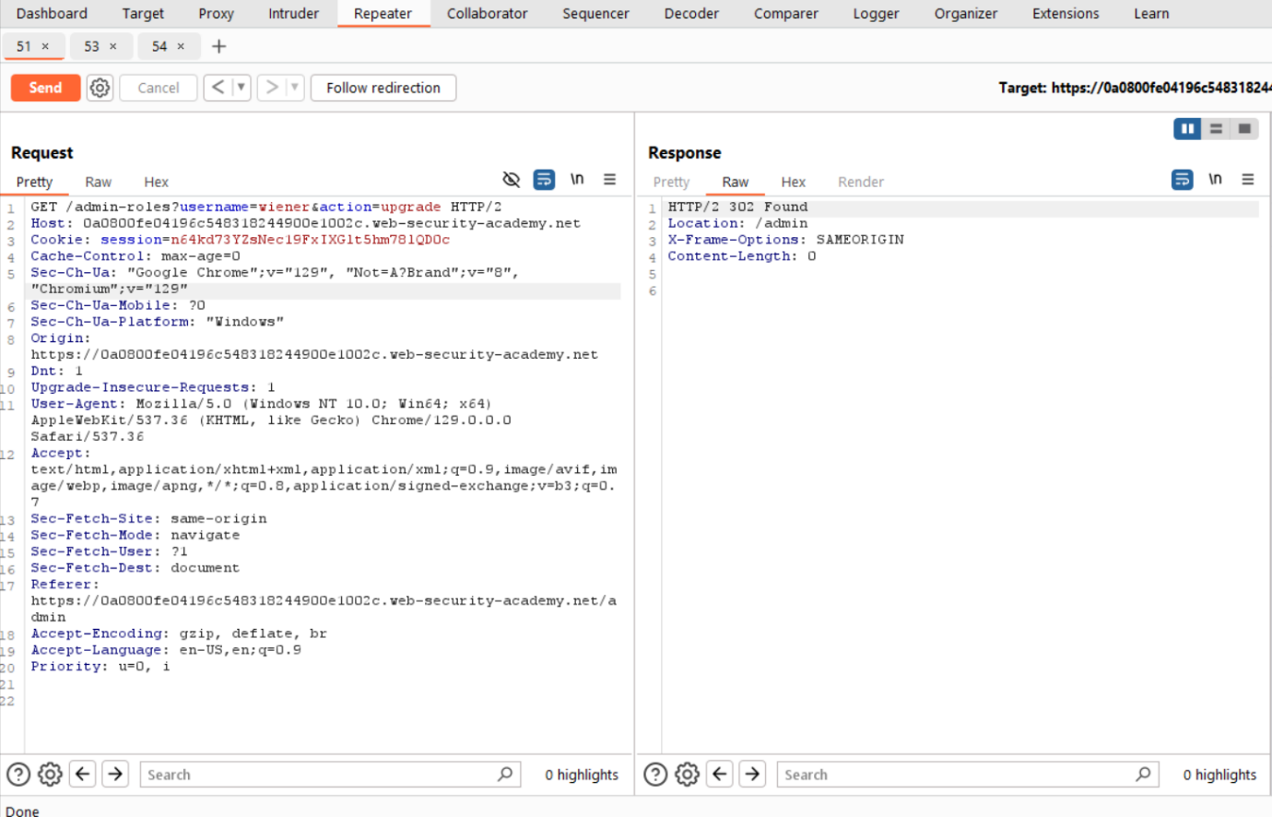

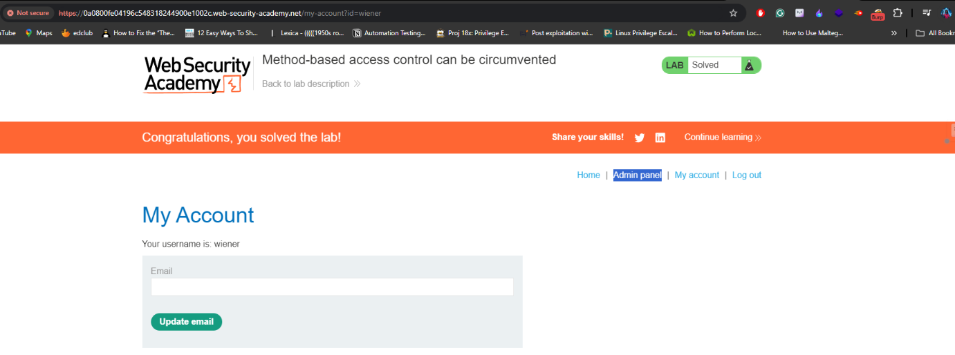

**Lab 12:** <https://portswigger.net/web-security/access-control/lab-multi-step-process-with-no-access-control-on-one-step>

Similar to previous lab but here we have another confirmation message from the server before doing the changes to any user. So, as usually I intercepted all the requests to modify after analysing the all requests I just copied the session id from the normal user and the pasted it on the verification url at the same time I also changed the username and finally the username is upgraded.

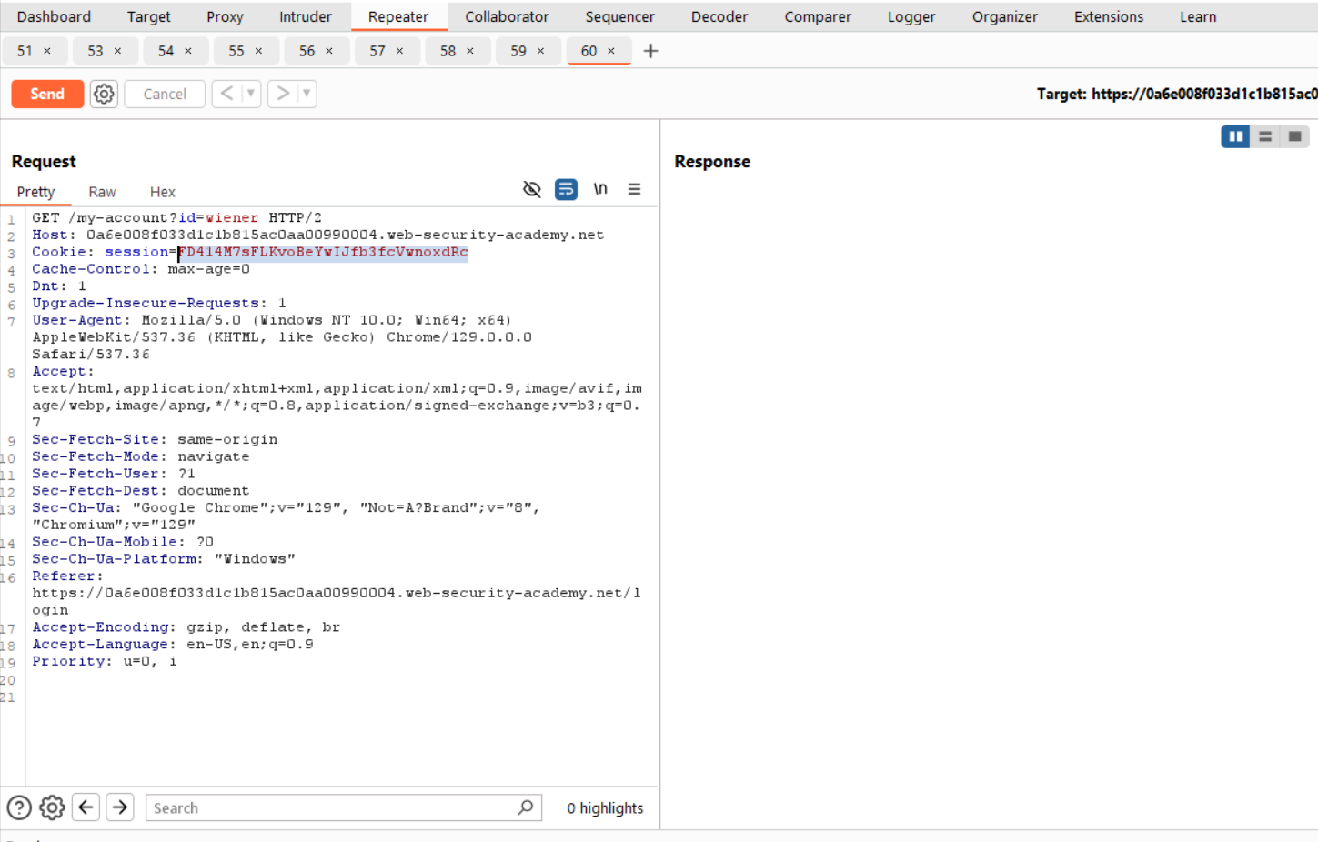

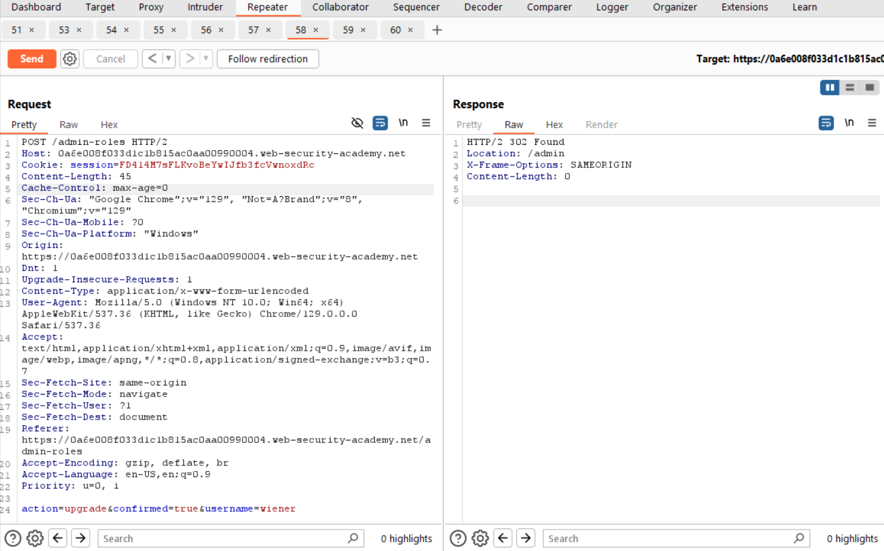

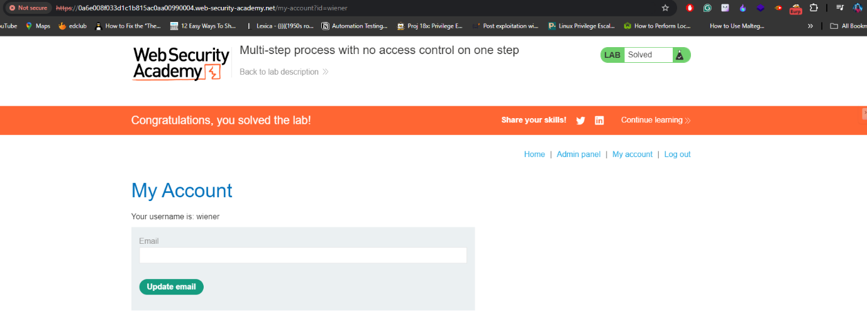

**Lab 13:** <https://portswigger.net/web-security/access-control/lab-referer-based-access-control>